Project Report

1. Introduction:

**1.1. Overview:**

Our project is AI recruiter where the Recruiter Bot shortlists the eligible candidates for Interview after chatting with them and analyzing their Education, work experience, skills, personality traits, etc. The details of the shortlisted candidates will be sent to the recruiter after which the company can communicate with him about the further procedure.

**1.2. Purpose:**

The purpose of this project is to help companies with high volume recruiting. It will enhance the communication between companies and candidates. The initial stage of recruiting can be efficiently accomplished using Bots.

2. Literature Survey:

**2.1. Existing problem:**

52% of talent acquisition leaders say that the most difficult part of their job is to shortlist the right candidate and 3% of candidates never hear back from a company after one touchpoint. On the flip side, it’s a challenge for employers to communicate well with all their candidates. For high volume recruiting, this would require communicating with thousands of candidates, in addition to a recruiter’s normal screening functions and other duties. Artificial Intelligence enabled software bots can definitely provide a solution for this problem.

**2.2. Proposed Solution:**

The AI recruiter will be present on a website where candidates can register themselves. After successful registration they will be provided job role options, they can choose to apply for the desired job role. Once they choose the job roles the chatbot will interact with them to know their education, work experience, skills, personality traits, etc and shortlist the eligible candidates. The shortlisted candidates have to then fill their details which will be mailed to the recruiter after which the rest of the recruiting process can happen.

3. Theoretical Analysis:

**3.1. Block Diagram:**

Registration form creation

Job roles page creation

Chatbot creation

Confirmation form creation

**3.2. Hardware/Software designing:**

We have created website/UI using Node-red services.

The chatbot has been created using Watson Assistant.

Data is stored in cloudant database

4. Experimental Investigations:

4.1.

We have investigated about the different functions provided by Node-red, explored different nodes and their functions, different features of IBM Watson Assistant, Cloudant and DB2 databases.

Also we got a hand on, on HTML and JavaScript, Node-red and watson assistant too

5. Flowchart:

Registration form creation

Job roles page creation

Chatbot creation

Confirmation form creation

6. Result:

We have successfully created the chatbot which can shortlist the candidates according to his/her capabilities. The details of the shortlisted candidates are sent to the recruiter. Hence the efficient working of the AI recruiter can be seen through this project.

Candidate Registration form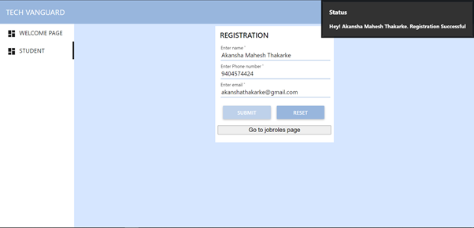

Jobroles page:

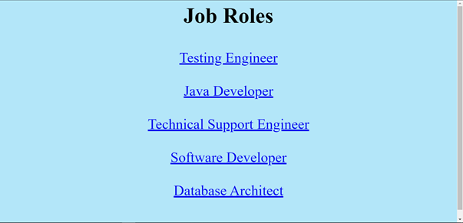

Chatbot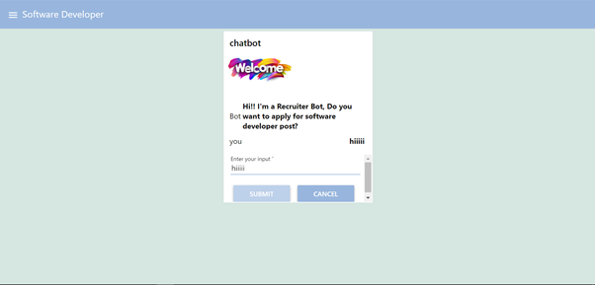

Confirmation page

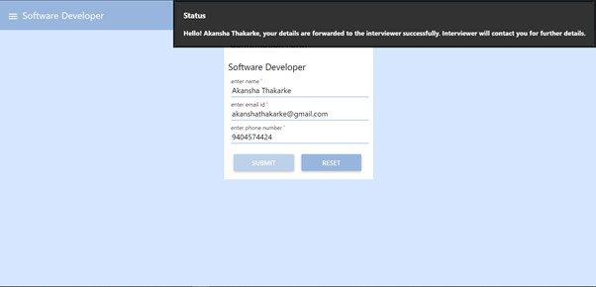

Email recieved by interviewer/recruiter

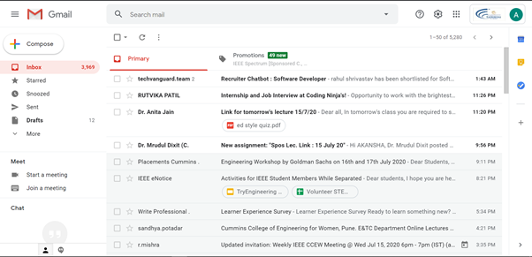

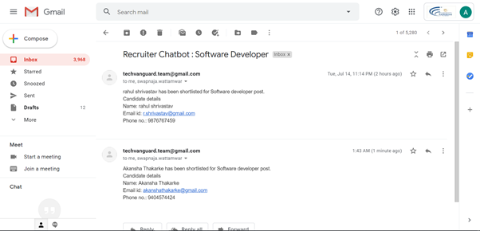

7. Advantages and Disadvantages:

**7.1. Advantages:**

i. This Recruiter can help companies in mass recruiting.

ii. The manual errors can be reduced.

iii. The communication between the candidates and the companies will improve.

iv. Eligible candidates will be shortlisted.

v. Candidates can understand their eligibilites and capabilities.

**7.2. Disadvantages:**

i. The disadvantage of the AI recruiter is lack of humanness.

ii. It should not replace humans and create unemployment.

8. Applications:

The AI recruiter can be used by companies for shortlisting the candidates for interviews.

9. Conclusion:

The AI recruiter solves many problems such as communication between candidates and companies, reduces human errors, etc but it should not endanger the job of people.

It has many advantages and has a huge future scope.

10. Future Scope:

Robots are the future as they are efficient and reduce manual errors.

The AI recruiter is an efficient tools for mass recruiting in the nearing future.

The robots can be trained to do such tasks for facilitating the recruitment process.

 11. Bibilography:

https://ideal.com/recruitment-chatbot/

<https://chatbotsmagazine.com/how-to-develop-a-chatbot-from-scratch-62bed1adab8c>

https://www.16personalities.com/free-personality-test

<https://www.youtube.com/watch?v=NCSzqhNR-lk&t=9432s>



12. Appendix:

**Source code:**

1. Node-red networks for UI

<https://github.com/SmartPracticeschool/SBSPS-Challenge-3021-AI-RECRUITER---CHATBOT>

2. Code for Main Chatbot

<https://github.com/SmartPracticeschool/SBSPS-Challenge-3021-AI-RECRUITER---CHATBOT/blob/master/skill-Software-Developer-Bot.json>

3. Video Link <https://drive.google.com/drive/folders/1VCFFMf7okbBlBG8Pof46XqAOqPo5fTTM?usp=sharing>